# Sorting of color/pixel

Develop a program which generates randomly pixels and sort them by color. The UI should look like the following pictures. The start screen should look like picture 1.

After pressing random color button the panel should be filled randomly with pixels in different colors (Picture 2). Second after pressing the color sorting button the generated pixels should be sorted via the “HUE” value (Picture 3).

Note:

It is expected that the UI is designed in WPF, the common architectural patterns and unit test are considered.

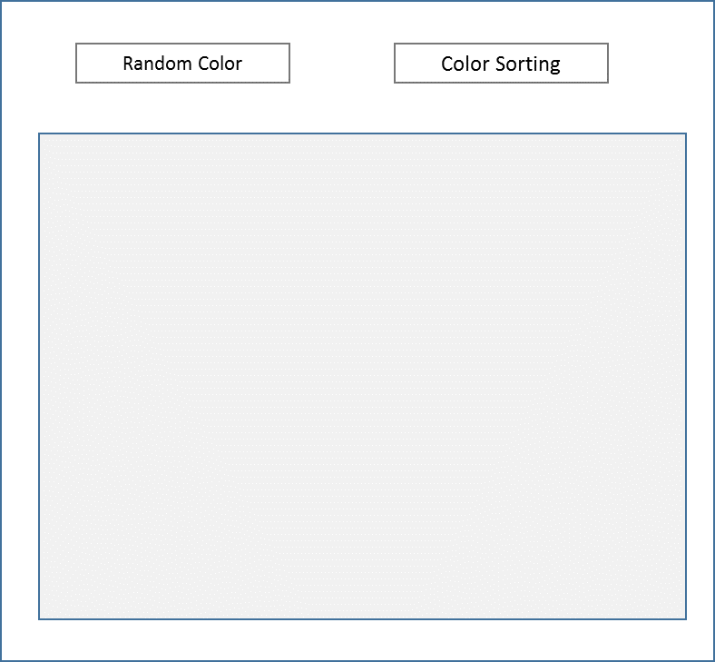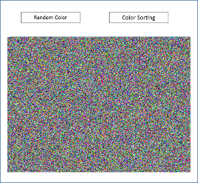

Picture 1 Picture 2

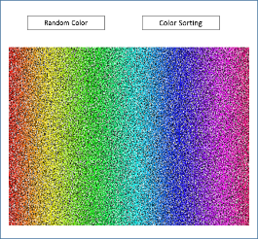

Picture 3